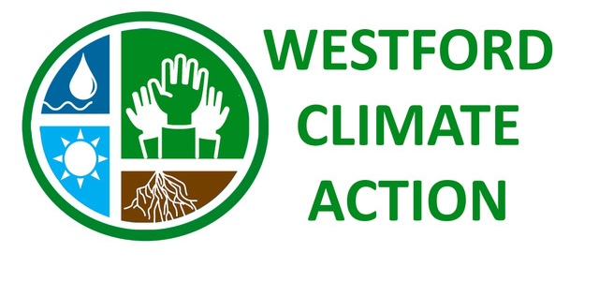

PRESS RELEASE
Contact: Emily Teller
eteller@earthlink.net
978-884-4473
Our Climate. Our Future. Our Choices.
From Climate Science to Local Action

Wednesday, September 30, 7:00 PM, First Parish Church United, 48 Main Street, Westford
FREE and ALL ARE WELCOME

What does the latest climate science tell us about our future – and what can communities like Westford do about it? Join Westford Climate Action for an engaging presentation featuring Dr. Jeffrey Basara, Department Chair and Professor of Environmental, Earth and Atmospheric Sciences at UMass Lowell.
UMass Lowell is a national leader in sustainability research and education. Since 2019, the university has received more than $120 million in research funding focused on climate, sustainability and related areas. Its Rist Institute for Sustainability and Energy brings together faculty, students and researchers from across the university to turn climate and energy research into innovation and real-world solutions. The Institute’s goal is to create blueprints for human-scale sustainability in communities throughout our region and across the world.

What does this mean for our communities?
Dr. Basara will connect the latest climate science with the challenges and opportunities facing communities today. He will explore:
- What the latest climate science tells us—and why action matters now
- Breakthrough climate and energy research underway at UMass Lowell
- How the Rist Institute is turning research into innovation and solutions
- Education and career opportunities for the next generation of climate and sustainability leaders
- How Westford and other communities can partner with UMass Lowell on climate action

Dr. Basara's research examines the complex connections among weather, climate, water and ecosystems, with particular emphasis on extreme precipitation and its impacts. He is also deeply committed to teaching and mentoring students and preparing the next generation of environmental and climate leaders. https://www.uml.edu/sustainability/

Come learn about the science, discover what is happening at UMass Lowell, and explore how research, innovation and community engagement can translate into meaningful local climate action.
Join us for an informative evening—and a conversation about our climate, our future, and our choices.

This event is jointly sponsored by Westford Climate Action and Westford’s Clean Energy and Sustainability Committee. https://westfordclimateaction.org/

